

|  |  |  |  |  |  |
| --- | --- | --- | --- | --- | --- |
| Programme | : | B.Tech | Semester | : | Winter 19 - 20 |
| Course | : | Database Management Systems | Code | : | CSE2004 |
| Faculty | : | Dr.Bhuvaneswari A &Dr.Ayesha Sheik | Slot | : | L27 + L28 |
| Ex. No. | : | 10 | Date | : | 06.03.2020 |

**Wilson Vidyut Doloy**

**19BCE1603**

**Triggers in SQL**

1. Consider the table Employee Table

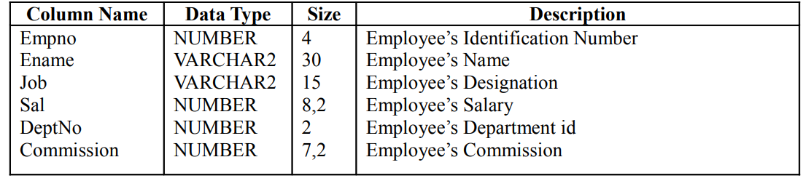

1. Create a trigger message that “a new row is inserted” after the record is added successfully.
2. Write a before delete trigger on Employee table. (If the entire record of an Employee is attempted to delete)
3. Write a trigger, for every any update on the salary column, the updated row is inserted into a new table.
4. Store the count of employees having salary > 40000 in new table Audit
5. Give 10% raise to all employees whose salary > 30000.
6. For given table, create “Before Update” trigger preventing a change on Primary Key column

**i)**

create or replace trigger message

after insert on employee

for each row

begin

dbms_output.put_line('New row Inserted');

end;

/

Trigger created.

insert into employee values(1001,'Wilson','HR',40000.25,12,3000.75);

New row Inserted

**ii)**

create or replace trigger message1

before delete on employee

for each row

begin

dbms_output.put_line('Row will be deleted');

end;

/

Trigger created.

delete from employee where empno=1001;

Row will be deleted

**iii)**

create or replace trigger message1

after update of sal on employee

for each row

begin

insert into emplyee1 values (select * from employee where sal=NEW.sal);

dbms_output.put_line(‘Table updated’);

end;

/

Trigger created.

update employee

set sal=sal-0.3*sal

where sal>50000;

Table updated

**iv)**

create or replace trigger up2

after insert on employee

for each row

begin

insert into audit values (select count(*) from employee where sal>40000);

dbms_output.put_line(‘Audit table updated’);

end;

/

Trigger created.

insert into employee values(1001,'Wilson','HR',40000.25,12,3000.75);

Audit table updated

**v)**

create or replace trigger up3

after insert on employee

for each row

begin

update employee

set sal=sal+0.3*sal

where sal>30000;

dbms_output.put_line(‘Salary increased’);

end;

/

Trigger created.

insert into employee values(1001,'Wilson','HR',40000.25,12,3000.75);

Salary increased

**vi)**

create or replace trigger up4

before insert on employee

for each row

begin

dbms_output.put_line(‘Update not allowed’);

end;

/

Trigger created.

update employee

set empno=1008

where empno=1001;

Update not allowed